SIMATS ENGINEERING (SAVEETHA SCHOOL OF ENGINEERING)
Department of Computer Science and Engineering
CO1 ASSESSMENT TOOL 1 – Case Study Analysis
Course Code: | CSA10 / CSA1001 | Course Title: | Software Engineering
CO Assessed: | CO1 | Assessment: | Assessment Tool 1 – Case Study Analysis
Weightage: | 20% | Total Marks: | 25
CO1 Statement: | Apply advanced methodologies and agile project management techniques to manage software projects effectively
Student Name: | Mohamed saif.A | Reg. No.: | 192521171
Date: | 01.10.26 | Duration: | 60 minutes

Code of Conduct
I Mohamed saif.A /192521171__________________________ (Name / Reg No) certify that this submission is my original work and that I have adhered to the guidelines specified for this assessment. I understand that any violation of academic integrity rules will result in disciplinary action.
Signature of the Student: _________________________
Annexure A – Case Study Analysis
Instructions to Students:
Each student will be allotted one problem statement. Analyze the assigned problem systematically by following the steps given below. Your report should demonstrate your understanding of software engineering concepts and your ability to design an appropriate software solution.
Based on your allotted problem statement, prepare a report by answering the following questions:
- Understand the Problem Statement
  - Explain the problem in your own words.
  - Identify the objectives of the proposed system.
  - State the scope of the problem.
- Identify Key Stakeholders and Challenges
  - Identify all the stakeholders involved in the system.
  - Explain the roles and responsibilities of each stakeholder.
  - Discuss the major challenges and issues faced by the stakeholders.
- Analyze the Current Approach
  - Describe the existing system or current process.
  - Identify its strengths and limitations.
  - Analyze the problems or gaps that need to be addressed.
- Propose a Suitable Solution Using Software Engineering Principles
  - Design a software-based solution for the given problem.
  - Describe the major functional modules of the proposed system.
  - Identify the functional and non-functional requirements.
  - Explain how software engineering principles such as modularity, scalability, maintainability, reliability, usability, and security are incorporated into your solution.
- Justify the Chosen Methodology/Framework
  - Select an appropriate Software Development Life Cycle (SDLC) model or software development framework (e.g., Agile, Scrum, Waterfall, Spiral, DevOps).
  - Justify why the selected methodology/framework is suitable for the proposed system.
  - Explain how it supports successful project development and maintenance.
- Discuss Expected Outcomes and Limitations
  - Describe the expected benefits of the proposed solution.
  - Explain how the solution addresses the identified challenges.
  - Discuss potential risks, implementation challenges, and limitations.
  - Suggest possible future enhancements.
Rubrics for Calculation
Criteria | Excellent (5 Marks) | Good (3 Marks) | Satisfactory (2 Marks) | Needs Improvement (1 Mark)
Problem Understanding (30%) | Clearly explains the problem, objectives, and scope with complete understanding. | Explains the problem with minor omissions. | Basic understanding with limited explanation. | Poor understanding; objectives and scope are unclear or missing.
Stakeholder & Challenge Analysis (25%) | Identifies all stakeholders, their roles, and challenges with clear analysis. | Identifies most stakeholders and challenges with adequate analysis. | Identifies only a few stakeholders or challenges. | Stakeholders and system analysis are incomplete or inaccurate.
Current System Analysis (20%) | Thoroughly analyzes the existing system, strengths, weaknesses, and identifies all gaps. | Good analysis with most strengths and weaknesses identified. | Limited analysis with partial identification of issues. | Proposed solution is unclear or inappropriate; requirements are largely missing.
Proposed Software Solution & Software Engineering Principles (15%) | Proposes an innovative, feasible solution applying appropriate software engineering principles (modularity, scalability, maintainability, security, etc.). | Suitable solution with good application of software engineering principles. | Basic solution with limited application of software engineering principles. | Methodology is inappropriate, poorly justified, or not discussed.
Methodology/ Framework Justification (10%) | Selects the most suitable SDLC/model/framework and provides strong technical justification. | Suitable methodology selected with adequate justification. | Methodology selected but justification is weak. | Outcomes, limitations, or future enhancements are missing; report lacks organization and clarity.

Criteria | Mark
Problem Understanding (30%) | /5
Stakeholder & Challenge Analysis (25%) | /5
Current System Analysis (20%) | /5
Proposed Software Solution & Software Engineering Principles (15%) | /5
Methodology/ Framework Justification (10%) | /5
TOTAL | /25

1. Understand the Problem Statement
1.1 Introduction
• Landslides are natural hazards that can cause serious damage to human lives, buildings, roads, agricultural land, communication infrastructure, and public facilities.
• They occur when soil, rocks, and other materials move downward along a slope.
• Heavy rainfall, soil saturation, slope changes, ground movement, deforestation, construction activities, and geological conditions can increase landslide risk.
• Traditional monitoring mainly depends on manual inspection, periodic measurements, rainfall information, and observations by local authorities.
• These methods are useful but may not continuously cover every vulnerable location.
• Rapid environmental changes may therefore be detected late.
• The proposed AI-Based Landslide Risk Monitoring and Early Warning System is a software-based solution.
• It continuously collects environmental and ground-condition information.
• It analyzes the collected data and estimates landslide risk.
• It generates warnings when dangerous conditions are detected.
• It supports early response and decision-making rather than physically preventing landslides.
1.2 Problem Description
• Manual monitoring may involve inspecting cracks, soil moisture, rainfall, ground movement, and slope conditions.
• Major limitations include non-continuous monitoring, difficult access during bad weather, limited geographical coverage, inconsistent recording, missed early changes, communication delays, and limited use of historical data.
• The proposed system integrates sensors, software, AI/ML, a centralized database, a monitoring dashboard, and alert mechanisms.
• It collects and analyzes relevant environmental and ground-condition data.
• It classifies landslide risk as Low, Moderate, High, or Critical.
• It displays the risk level to authorized users for timely action.
1.3 Objectives
• Continuously monitor rainfall, soil moisture, slope movement, and other available parameters.
• Use AI/ML to analyze collected and historical data and estimate landslide risk.
• Generate early warnings when predefined or AI-detected risk conditions occur.
• Centralize sensor measurements, predictions, alerts, and historical records.
• Provide a real-time dashboard showing environmental conditions, risk levels, and sensor status.
• Support faster and better-informed decisions by disaster-management personnel.
• Use historical data to identify patterns and improve future prediction models.
Software Engineering – CO1 Case Study Analysis |
1.4 Scope, Inputs, Processing and Outputs
• Collect environmental and ground-condition data from monitoring locations.
• Support sensor communication and data transmission.
• Perform data preprocessing and centralized storage.
• Apply AI-based risk analysis and classify risk levels.
• Provide dashboard visualization, automatic warnings, notifications, historical analysis, sensor-status monitoring, and report generation.
• The system can be deployed in hilly regions, roads near slopes, residential areas near mountains, and other vulnerable locations.
• The system does not replace professional geological investigations or emergency-management decisions.
• It functions as a monitoring and decision-support system.

2. IDENTIFY KEY STAKEHOLDERS AND CHALLENGES
2.1 Major Stakeholders
• Disaster Management Authorities: Monitor risk, receive alerts, coordinate emergency response, and review reports.
• Local Government Authorities: Monitor vulnerable areas, coordinate response, and support safety or evacuation measures.
• Residents: Require timely, understandable, and location-specific warnings and emergency instructions.
• Emergency Response Teams: Respond to alerts, reach affected areas, support rescue operations, and coordinate with authorities.
• Geologists and Environmental Experts: Analyze conditions, validate system outputs, and support model improvement.
• System Administrators: Manage users, servers, databases, security, and software updates.
• Sensor/Hardware Maintenance Team: Install, calibrate, repair, and monitor sensors and communication equipment.
• Software Development Team: Analyze requirements, develop and integrate AI/database components, test the system, and perform maintenance.

2.2 Stakeholder Challenges
• Data Accuracy: Incorrect sensor readings can affect AI predictions; calibration and validation are essential.
• Network Connectivity: Remote landslide-prone areas may have unreliable communication.
• Real-Time Processing: Incoming data must be processed quickly enough to support effective monitoring.
• False Alerts: Incorrect predictions may cause unnecessary warnings; thresholds and models require proper validation.
• Missed Alerts: Failure to detect dangerous conditions can have serious consequences; continuous monitoring and model validation are required.
• Sensor Failure: Environmental conditions, power problems, physical damage, or communication failures can interrupt sensing.
• Security: Unauthorized users must not be allowed to modify risk information, user accounts, or system configurations.
• User Understanding: Warnings should be simple, clear, and easy to interpret immediately.
• Large Data Volume: Continuous sensor monitoring produces large datasets that require efficient storage and processing.
• AI Model Reliability: Models require suitable historical data, proper training, testing, and continuous monitoring.

3. ANALYZE THE CURRENT APPROACH
3.1 Existing Monitoring Approach
• Traditional landslide monitoring may include manual inspection, periodic field surveys, rainfall monitoring, geological observation, reports from local people, individual sensor measurements, and manual communication of warnings.
• Field personnel may inspect cracks, erosion, drainage, slope movement, and other visible warning signs.
• Rainfall is monitored because prolonged or intense rainfall can contribute to unstable slopes, although rainfall alone does not provide a complete picture of risk.
3.2 Strengths
• Human expertise can identify physical conditions that software may not easily represent.
• Direct observation allows personnel to identify cracks, erosion, and visible slope changes.
• Manual systems can be simple to implement without complex software infrastructure.
• Experienced personnel can combine different observations during decision-making.
3.3 Limitations
• Manual monitoring cannot continuously observe every location.
• Periodic inspections may miss rapid changes between visits.
• Large areas are difficult to cover with limited personnel.
• Data recording and interpretation may contain human errors.
• Traditional processes may lack automated prediction using historical data.
• Warnings can be delayed while information is communicated between people.
• Different data sources may remain separated.
• Manually recorded data may be difficult to use for efficient AI analysis.
3.4 Gaps in the Existing System
Existing Gap | Proposed Improvement
Manual monitoring | Automated continuous monitoring
Delayed detection | Real-time data processing
Separate data sources | Centralized database
Manual risk assessment | AI-based risk classification
Limited alerts | Automated notification system
Difficult historical analysis | Historical dashboard and reports
Limited coverage | Multiple monitoring stations
Sensor problems not immediately visible | Sensor-health monitoring
3.5 Need for the Proposed System
• The proposed system addresses the identified gaps by integrating sensors, software, AI, database technology, visualization, and alert mechanisms into one platform.
• Continuous data collection and dashboard presentation improve information availability.
• The system can support authorities in making timely and informed decisions.

4. PROPOSE A SUITABLE SOLUTION USING SOFTWARE ENGINEERING PRINCIPLES
4.1 Proposed System
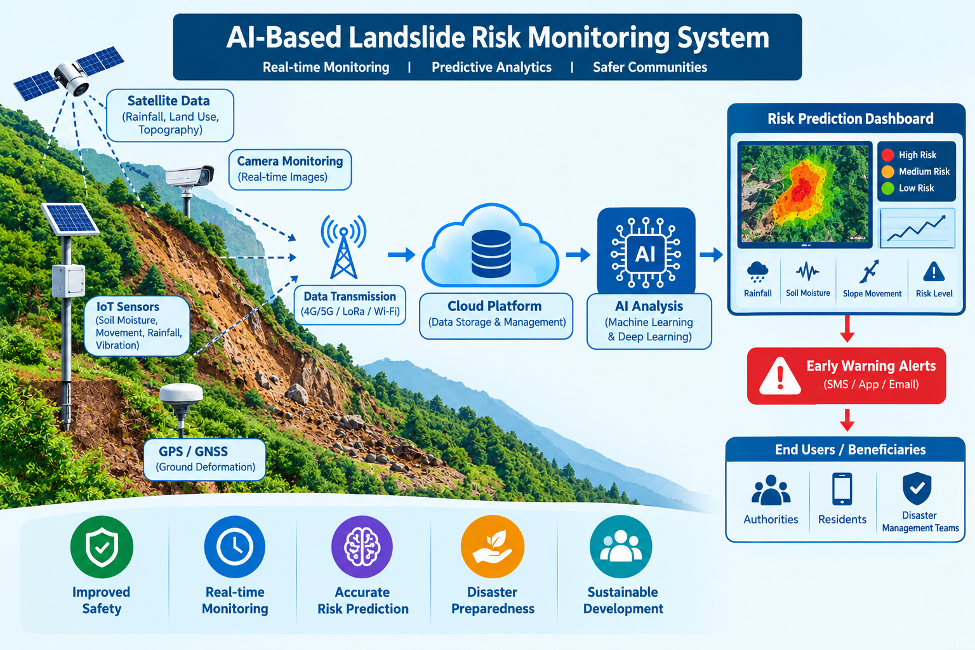
4.2 Major Functional Modules
• User Management: Handles registration, login, authentication, roles, passwords, and access control.
• Sensor Data Collection: Receives and validates rainfall, soil moisture, movement, temperature, humidity, and slope measurements.
• Data Preprocessing: Handles missing values, noise, normalization, and data formatting.
• AI Prediction: Analyzes environmental features using a model trained and tested with suitable historical data.
• Risk Classification: Converts AI output into Low, Moderate, High, and Critical risk categories.
• Monitoring Dashboard: Displays current risk, sensor values, locations, historical graphs, alerts, and system status.
• Alert and Notification: Sends dashboard, SMS, email, or mobile notifications and maintains alert history.
• Database: Stores users, sensors, measurements, predictions, risk levels, alerts, historical records, and logs.
• Reporting: Generates daily, weekly, sensor-performance, alert, and historical-risk reports.
4.3 Functional Requirements
• Authorized users shall be able to log in.
• The system shall collect sensor data.
• The system shall validate and store sensor readings.
• The system shall process incoming data.
• The system shall execute the AI prediction model.
• The system shall classify landslide risk.
• The system shall display current risk levels.
4.4 Non-Functional Requirements
• Performance: Process incoming data efficiently and display results without unnecessary delay.
• Reliability: Continue operating reliably and detect failures wherever possible.
• Availability: Keep monitoring services available, especially during periods of increased risk.
• Scalability: Support additional sensors and monitoring locations.
• Security: Implement authentication, authorization, encrypted communication, secure database access, and audit logging.
• Usability: Provide a simple dashboard that users can understand quickly.
• Maintainability: Use independent modules so components can be modified without affecting the entire system.
• Accuracy: Train and evaluate the AI model properly before using it for operational decision support.
4.5 Software Engineering Principles
• Modularity: Separate authentication, sensor management, preprocessing, AI, risk classification, dashboard, notification, and reporting modules.
• Scalability: Allow new sensors and monitoring locations to be added without redesigning the complete system.
• Maintainability: Use structured code, documentation, modular architecture, testing, and version control.
• Reliability: Detect sensor, communication, and server failures and provide backup and recovery mechanisms.
• Usability: Present important risk information clearly without requiring users to interpret complex AI output.
• Security: Use authentication, role-based authorization, secure communication, password protection, database security, and audit logs.
4.6 Suggested Layered Architecture
• Sensor Layer: Collects environmental and ground-condition data.
• Communication Layer: Transfers sensor data to the central server.
• Application Layer: Validates and processes information.
• AI Layer: Analyzes data and predicts landslide risk.
• Database Layer: Stores current and historical information.
• Presentation Layer: Provides web/mobile dashboards.
• Notification Layer: Sends alerts to authorized users.

5. JUSTIFY THE CHOSEN METHODOLOGY / FRAMEWORK
5.1 Selected Methodology – Agile Scrum
• Agile Scrum is selected because the proposed system contains multiple components and requirements may evolve during development.
• Scrum supports incremental development, continuous stakeholder feedback, flexible requirements, early testing, and early identification of technical risks.
5.2 Why Agile Scrum is Suitable
• Incremental Development: Divide the system into manageable increments instead of developing the complete system at once.
• Continuous Feedback: Allow stakeholders to review each increment and confirm whether the dashboard and alerts meet their needs.
• Flexible Requirements: Prioritize and implement new requirements in later sprints.
• Early Testing: Test each module during development instead of waiting until final completion.
• Risk Reduction: Identify technical issues, such as sensor communication problems, before complete system integration.
5.3 Example Sprint Plan
Sprint | Main Work
Sprint 1 | Requirement analysis and user management
Sprint 2 | Sensor-data collection
Sprint 3 | Database and data processing
Sprint 4 | AI prediction module
Sprint 5 | Monitoring dashboard
Sprint 6 | Alerts and notifications
Sprint 7 | Integration and testing
5.4 Scrum Roles and Activities
• Product Owner: Represents stakeholder requirements and prioritizes the product backlog.
• Scrum Master: Supports the Scrum process and removes development obstacles.
• Development Team: Develops, tests, integrates, and maintains the system.
• Product Backlog: Contains requirements for login, sensor registration, data collection, AI, dashboard, notifications, and reporting.
• Sprint Planning: Selects tasks for the upcoming sprint.
• Daily Scrum: Discusses progress, current work, and problems.
• Sprint Review: Demonstrates completed functionality to stakeholders.
• Sprint Retrospective: Identifies improvements for the next sprint.
5.5 Agile Development and Maintenance
• The development cycle is: Requirements → Product Backlog → Sprint Planning → Development → Testing → Review → Feedback → Next Sprint.
• After deployment, improvements can be added through the product backlog.
• Future backlog items may include new sensors, AI-model improvements, satellite data, mobile applications, additional notification methods, and dashboard enhancements.
Software Engineering – CO1 Case Study Analysis

6. EXPECTED OUTCOMES AND LIMITATIONS
6.1 Expected Outcomes
• Continuous Monitoring: Receive and process data from connected monitoring locations.
• Faster Risk Identification: Automated processing can identify changing conditions more quickly than periodic manual observation alone.
• Early Warning Support: Generate alerts when predefined or AI-based risk conditions are detected.
• Centralized Information: Provide measurements, predictions, and alert history through one platform.
• Better Data Analysis: Use historical data to identify patterns and improve the AI model.
• Improved Coordination: Allow authorized stakeholders to access common monitoring information.
• Reduced Manual Work: Automate repetitive data collection and data-entry activities.
• Scalable Monitoring: Add sensors and monitoring locations as the system expands.

6.2 How the Solution Addresses Challenges
Challenge | Proposed Solution
Manual monitoring | Automated sensor monitoring
Delayed information | Continuous data collection
Large geographical areas | Multiple monitoring stations
Data management | Centralized database
Risk analysis | AI-based prediction
Warning delay | Automated alerts
Sensor failure | Sensor-health monitoring
Difficult historical analysis | Historical dashboard
Unauthorized access | Authentication and authorization
Changing requirements | Agile development

6.3 Potential Risks and Mitigation
• Sensor Failure: Use sensor-health monitoring, regular calibration, maintenance, and redundant measurements where appropriate.
• Communication Failure: Use local buffering, retry mechanisms, and alternative communication methods where feasible.
• Incorrect AI Prediction: Use suitable training data, model validation, testing, monitoring, and expert review.
• False Alerts: Combine relevant measurements and validate thresholds using historical data.
• Missed Warning: Use continuous model evaluation, multiple parameters, system-health checks, and expert oversight.
• Cybersecurity Threats: Apply authentication, authorization, and encryption, secure coding, monitoring, and regular security testing.

6.4 Implementation Challenges
• Installation and maintenance of sensors.
• Availability of sufficient historical data.
• Selection and validation of a suitable AI model.
• Reliable network connectivity in remote locations.
• Adequate power supply for remote monitoring sensors.
• Integration of hardware and software.
• Protection against cybersecurity threats.
• Training users to operate the monitoring dashboard.
• Managing large volumes of sensor data.
• Maintaining continuous system availability.

6.5 Limitations of the Proposed System
• Prediction Is Not Guaranteed: AI predictions are estimates based on available data and do not provide absolute certainty.
• Dependence on Sensors: Prediction quality depends on the quality and availability of input data.
• Historical Data Requirement: Limited or biased training data can affect model performance.
• Connectivity: Real-time monitoring can be affected by communication failures.
• Power Requirements: Remote stations require reliable power or suitable backup systems.
• Maintenance: Sensors and software require regular maintenance.
• Cost: Large-scale deployment may require substantial investment in sensors, communication, servers, and maintenance.

6.6 Future Enhancements
• Satellite Data Integration: Add geographical information from satellite sources.
• Drone-Based Monitoring: Collect visual information from difficult-to-access locations.
• Advanced AI Models: Evaluate suitable machine-learning or deep-learning approaches.
• Mobile Application: Provide risk information and alerts to authorized users and communities.
• GIS Integration: Display risk levels on maps.
• Multi-Sensor Fusion: Combine rainfall, soil moisture, ground movement, and other measurements.

